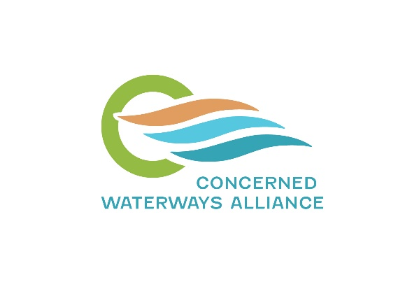
15th November 2024
To:
Water team
Price Monitoring and Regulation division
Essential Services Commission
Level 8, 570 Bourke Street
Melbourne
Victoria 3000
water@esc.vic.gov.au

Essential Services Commission Review of New Customer Contributions

Thank you for the opportunity to make a submission to the review of new customer contributions by the Essential Services Commission (ESC).
The Concerned Waterways Alliance (CWA) is a network of community and environment groups from Gippsland to the Otways. We share a deep concern about the degraded state of southern Victoria’s rivers, wetlands, and aquifers, and are committed to improving their health for the benefit of current and future generations.
The CWA has two main areas of concern that we would like the Commission to consider, with examples from the Barwon region:
- How changes to the guidance provided to water authorities by the ESC may impact Integrated Water Management (IWM) initiatives—either positively or negatively. This includes examining whether proximity to waterways should be a valid reason for water authorities to adjust customer contributions.
- Whether the new customer contribution can serve as a disincentive for development in areas with identified overallocation of existing water resources or other environmental considerations.

Potential Impact on Integrated Water Management (IWM) Initiatives
The Victorian Government has been heavily invested in rolling out IWM initiatives across the state, supported by actions in the Central and Gippsland Region Sustainable Water Strategy (CGRSWS) and the establishment of regional Integrated Water Management forums alongside local IWM policy development. Water authorities have led these regional IWM forums, recognizing their pivotal role in the success of IWM projects.
Two core aims of IWM projects are to enable potable water substitution (and in some cases, contribute to potable supplies) and to protect waterways from stormwater runoff. For instance, the stormwater harvesting grid proposed by Barwon Water at Torquay plans to treat stormwater runoff from new developments for reuse. Without this initiative, runoff would further contribute to damaging flows into the nationally significant Karaaf Wetlands. Additionally, this project would supply water for irrigation to businesses in the Surf Coast hinterland, thereby reducing demand on potable water supplies.
Another example is the proposed harvesting of stormwater from Geelong’s planned western and northern growth areas. Without intervention, these developments would significantly impact the nearby Moorabool River. Barwon Water is currently assessing the feasibility of capturing stormwater runoff from these growth areas and directing it to agricultural customers in the Moorabool Valley as well as customers in Geelong’s northern industrial zones.
The CWA recommends that the ESC recognize that developer contributions—particularly from new subdivisions—are a critical component in the viability of IWM initiatives that reduce potable water demand and protect waterways. New customer contribution changes should support, not impede, IWM initiatives and allow water authorities flexibility to pursue such initiatives, particularly in greenfield areas where they are most easily implemented and cost effective.

Consideration of Environmental and Social Factors in New Customer Contributions
The CWA supports the principle that the NCC framework “sends signals to developers about the cost of developing in different locations.” We believe that water authorities should have the ability to consider both environmental and social factors when configuring new customer contribution agreements.
For example, augmentation for a coastal town such as Lorne with limited catchment options will further stress Otway coastal waterways unless recycling or desalination options for potable water are explored. Since these costs arise largely due to tourist demand and the resulting seasonal spike in water demand, it is likely that distributing these costs over the broader Geelong region may be questioned from a social license perspective.
By contrast, smaller country towns often face challenges in the rollout of sewerage infrastructure due to perceived lack of viability and a reluctance by water corporations to invest. For example, the reluctance of Barwon Water to implement sewerage services in the town of Meredith has led to septic systems on lots as small as 1,000m², with a damaging impact on the nearby Coolebargurk Creek.
As outlined in a recent report: “Under the previous DWMP, Meredith and Inverleigh were considered the highest priority for sewerage feasibility investigation. A stormwater quality monitoring study was carried out as a result. The study concluded that the water quality of Coolebargurk Creek at Meredith was at a level that precluded recreation, aesthetic enjoyment, stock watering, irrigation, and impacted aquatic ecosystems.”
Since development in Meredith is largely residential rather than for holiday accommodation, there would likely be broader social license to distribute sewerage infrastructure costs within the township over a wider area.

As the impact of climate change on water resources increases, the location of new developments with respect to both water availability and sewage treatment facilities will become increasingly important. Some catchments are already over-allocated and will not be able to support further development without significant investment in ‘manufactured water’ (as defined in the CGRSWS), while wastewater treatment plants will also come under pressure as the ability of receiving streams to cope with ever more concentrated effluent declines. Developer charges should reflect environmental externalities (as envisaged in the proposed National Water Agreement), which may vary considerably between catchments, and potentially act as a disincentive to development in areas which are least able to support increased extraction of water and where the impacts of stormwater or wastewater discharge on rivers and wetlands are greatest.

Finally, the CWA supports the proposed change in terminology from the current use of ‘new customer contributions’ to ‘developer charges’.

Conclusion
The CWA commends the Essential Services Commission for its commitment to reviewing policies and providing guidance to water authorities. We believe that addressing the challenges facing our water supply systems due to climate change will require a focused, adaptive management approach across relevant government agencies. We also appreciate the ESC's recognition of the importance of community consultation in making policy adjustments.

For further information, please contact Juliet Le Feuvre concernedwaterwaysalliance@gmail.com
15 November 2024

https://www.abc.net.au/news/2021-04-05/torquay-property-boom-puts-karaaf-wetlands-under-threat/100046260
https://www.geelongaustralia.com.au/futuregrowth/default.aspx
https://www.goldenplains.vic.gov.au/sites/default/files/2023- 07/Golden%20Plains%20DWMP%202023%20FINAL.pdf

