Business Case

New Stormwater Quality Treatment Systems

Program Intent | Maintenance of newly constructed stormwater quality treatment systems.
Program Lead | Daniel Besley, Team Leader, Catchments, Land and Waterways Services
Program Owner Group/Team/Section | Service Delivery – Asset Management Services  Catchment Asset Management  Catchments, Land and Waterways Services

Business case summary

This program delivers on Melbourne Water’s statutory and strategic drivers to protect Port Philip Bay (PPB) and Western Port from pollutants in stormwater runoff from new developments. The most efficient and effective approach to reduce pollutants in stormwater runoff is for land developers to build SWQTS consisting of sediment ponds and vegetated wetland waterbodies that remove sediment and nitrogen, respectively. These assets also create additional environmental and social values within new developments, benefiting the local communities.

Once constructed and handed to Melbourne Water for ongoing maintenance, these assets are managed under the SWQTS maintenance program, which is in three parts: maintenance of wetland waterbody vegetation and hydrology control structures (this program), maintenance of sediment ponds (separate program) and maintenance of amenity (separate program).

The State Environment Protection Policy (Waters) clause 34 requires owners of assets created to protect water quality including sediment ponds and wetland must ensure these assets are “maintained for the purposes for which they were constructed”. This obligation is also reflected in the Healthy Waterways Strategy. Within the Strategy, Regional Performance Objectives direct the management of all existing and all newly constructed stormwater quality treatment systems (SWQTS) over ten years from 2018, in accordance with compliance obligations.

Due to the projected growth in assets over the 5 years of the 2021-2026 Price Period, Melbourne Water has developed this business case in support of the increase in investment required above baseline (being the maintenance of the existing SWQTS asset portfolio). Without the increase in investment for the additional 45 SWQTS, it is almost certain that Melbourne Water will not be able to meet our compliance obligations for these assets, increasing the degree of risk to the environment from poorly maintained and failing assets.

The proposed program is prudent in that it represents a planned approach to maintenance of these additional assets, with the aim of maximizing their life by ensuring that they continue to function in accordance with their design intent for the projected life of the asset (usually ~25 years).

The proposed program is efficient because it is focused on delivering the least cost solution for meeting Melbourne Water’s statutory obligations. In this regard, only maintenance activities critical to the function of the asset are completed. The program’s planned works include: maintaining hydrological function, maintaining vegetation buffers and managing litter and debris for SWQTS function. Program costs were derived from detailed cost data underpinning Melbourne Water’s Stormwater Quality OPEX program, since the same suite of maintenance activities will be applied to newly constructed SWQTS.

Table 1: Program Benefits
Program benefits | Program costs
Output: Maintenance of an additional 45 SWQTS over 5 years (cumulative growth of ~9 per year)  Outcome: Sustained treatment of increased stormwater runoff to compliance obligations; with subsequent water quality benefits for receiving waters (waterways and Bays). | Approx. $7616.12 per wetland per year  $1.2M over 5 years

Program Drivers

The program is primarily driven by compliance with Melbourne Water’s legislative obligations for the management of SWQTS to protect receiving water quality in the Bays and waterways.

Obligations

Melbourne Water has statutory obligations under the Water Act (1989) and the Environment Protection Act (1970/2018) to manage waterway and drainage infrastructure and to improve stormwater quality in drainage systems. Various state legislative and policy instruments provide direction to Melbourne Water on management mechanisms and quality targets (Figure 1). The State Environment Protection Policy (Waters), Victorian Planning Provisions and Port Phillip Bay Environmental Management Plan require Melbourne Water to maintain SWQTS to reduce pollutant loads from waterways into the Bay. Recent clarification from the Environment Protection Authority has made it clear that Melbourne Water needs to maintain these assets so that they are performing at their intended design standard.
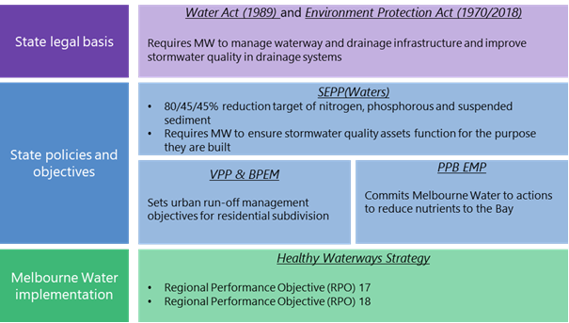
Figure 1 Summary of legislative and policy context for stormwater quality obligations

Strategic Drivers

Healthy Waterways Strategy
Our obligations are also reflected in the Healthy Waterways Strategy (HWS) Regional Performance Objectives, specifically:
RPO-17. Water quality in waterways and bays is improved by reducing inputs of sediment and other pollutants from urban construction and development.
RPO-18. Critical waterway health assets including stormwater treatment systems, fishways and erosion control structures, are maintained for their designed purpose or the same outcomes are delivered by alternative means.
The Healthy Waterways Strategy was co-designed with the community and other stakeholders, to ensure its priorities and objectives were those of all stakeholders. The strategy makes clear that by continuing our pre-2018 management approach, Melbourne Water is risking a noticeable and significant decline in waterway condition across the region within the ten year timeframe of the strategy. The strategy considers the needs of Port Phillip Bay and Western Port, and responds to the policy and regulatory directions relating to stormwater and pollutant impacts on bay health. It highlights that one of the seven key threats to waterways is urban stormwater, which is of a magnitude that should not be ignored, both in terms of the increased volume (quantity) and pollutants (quality) of stormwater runoff from increasingly urban areas. Constructed stormwater treatment systems are one of a number of possible solutions (along with harvesting and infiltration of stormwater) available to deliver the Strategy’s stormwater management targets.

Waterways and Drainage Investment Plan and 2021 Price Submission
Melbourne Water’s Statement of Obligations creates the obligation to develop a Waterway and Drainage Investment Plan (WDIP) that must consider any relevant Victorian waterway management strategy, regional catchment management strategy or catchment sub-strategy. The 2021-2026 WDIP seeks to ensure the effective and efficient delivery of our services, where benefits to the community exceed the costs which involved balancing investment with four key considerations:
- Meeting obligations, responsibilities and directions.
- Aligning with regional co-developed strategies that address the risks of climate change and urbanisation.
- Responding to customer and community engagement, including customers’ preferences and willingness to pay for our services.
- Ensuring our investment is efficient and effective.
The 2021-2026 WDIP informed Melbourne Water’s 2021 Price Submission. Incorporated into this was consideration of customer preferences and advice from Melbourne Water Subject Matter Experts, regarding what the optimal investment in SWQTS would be to meaningfully deliver towards the Performance Objectives in the Healthy Waterways Strategy.

Projected asset growth

Costs to maintain Melbourne Water’s SWQTS asset base are increasing in line with increasing asset base: an additional 45 SWQTS projects (110.1 Ha in total) have been designed and are scheduled for construction during the 21-26 price period representing an annual asset growth of 4% per annum over the period. A further 43 SWQTS (133 Ha in total) are forecasted to commence, but are not yet active projects (so not included in our estimates).
Further, proposed maintenance costs per wetland have been set at the lower than average cost based on existing activities and costs for the current portfolio of SWQTS. The overall program was costed on the basis of the expected total increase in the number of SWQTS (i.e. 45) and their expected size (vegetated area, in Hectares, Ha) needing management over the 5 years.
The proposed increase in investment for maintenance of new assets during the 2021-2026 Price Period effectively balances risk between Melbourne Water and our customers.
Program Objectives

This program has been developed to enable Melbourne Water to:
- Deliver on our statutory compliance obligations in relation to the management of SWQTS
- Respond effectively to the project growth in assets
- Contribute towards meeting Regional Performance Objectives RPO-17 and RPO-18 in the Healthy Waterways Strategy
- Meet community expectations upon Melbourne Water to manage SWQTS for the benefit to the health of our waterways and Bays.

Program Background

Melbourne Water has a statutory obligation to maintain the design performance of constructed stormwater quality treatment systems to protect receiving water quality in Port Phillip Bay and Western Port by reducing nitrogen, phosphorous and suspended sediment loads.
At the same time, the asset base is growing by about 4.1% per annum (developers hand over 9 new constructed wetlands each year).

This expenditure funds the SWQTS management activities to support the environmental values they provide.
Constructed stormwater treatment wetlands are one of a suite of options available to developers to meet Victorian Planning Provisions Clause 56 stormwater management objectives. They remove harmful pollutants from stormwater before it reaches waterways and bays. They also slow flows and store water (lessening the impact of wet weather flows on downstream waterways), reduce flooding, provide local cooling and space for recreational activities like bushwalking and birdwatching, and can be designed to provide a water source for irrigation. Many constructed wetlands are valued by their local community for their amenity.
Where catchment size is greater than 60ha, SWQTS are transferred to Melbourne Water for ongoing management following successful capital establishment.
SWQTS are complex and generally consist of a number of major functional components, but they broadly contain two components (see Figure 2):
- a sediment trap which captures heavier pollutants and sediment
- a wetland cell which removes nitrogen and other pollutants through a variety of physicochemical processes including biological and chemical uptake by microbes present on the surface of vegetation. Microbes that colonise in the vegetation convert nutrients in stormwater into less harmful forms (e.g. bacteria converts soluble nitrogen into harmless atmospheric nitrogen), protecting the water quality in waterways and bays.

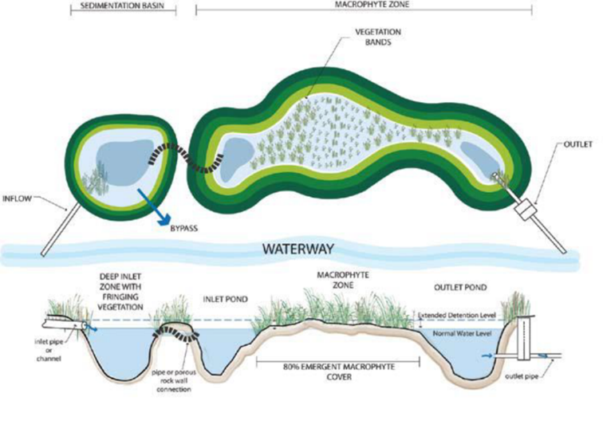
Figure 2 Indicative diagram of a constructed stormwater quality treatment system
Once constructed and handed to Melbourne Water for ongoing maintenance, these assets are managed under the SWQTS maintenance program, which is in three parts: maintenance of wetland waterbody vegetation and hydrology control structures (this program), maintenance of sediment ponds (separate program) and maintenance of amenity (separate program).

Program scope
This investment is a combination of proactive and reactive expenditure but is based on the likelihood of asset failure which is assessed for each SWQTS on handover. Melbourne Water’s constructed wetland design manual sets standards that aim to minimise the risk of failure of wetland assets and hence minimise maintenance activities and costs.
As part of the 2021 Price Submission, Melbourne Water is proposing an increase in its maintenance investment to facilitate maintenance of newly constructed SWQTS. Works will include:
- Maintaining hydrology
- Protecting or maintaining vegetation quality
- Maintaining civil structures
- Managing litter/debris

Program costs
The program’s cost have been derived based on driving efficiency and balancing risk between Melbourne Water and our customers.

Maintenance costs
A standard unit cost of $7,616.12 per system per annum has been used to forecast operational expenditure for SWQTS maintenance. The standard unit rate is based on an average cost from 2019-20 actuals. Maintenance activities undertaken on SWQTS and their typical costs are shown in Table 2. Maintenance costs for each system are ultimately determined based on a combination of their size and the level of risk assigned to the asset (should it fail to function and meet its design intent). Larger assets typically cost more to maintain (due to the greater area of vegetation and increased number of civil structures); and higher risk assets receive more frequent maintenance (and thus cost more to maintain) and vice versa. The standard unit cost is at the lower end of Estimated Unit Cost ranges.
Table 2: Programmed maintenance activities typically undertaken on constructed SWQTS
Maintenance Activity | Lower |  | Upper |  | Average
 | Frequency | Cost | Frequency | Cost | Frequency | Cost
Condition inspection | 1 | $49.00 | 1 | $1,162.00 | 1 | $261.00
Inlet inspect and clean | 2 | $25.00 | 3 | $306.00 | 2.5 | $77.00
Outlet inspect and clean | 4 | $15.00 | 12 | $800.00 | 8 | $72.00
Vegetation management (civil structures) | 0 | $56.00 | 1 | $2,272.00 | 0.5 | $466.00
Vegetation management (safety) | 2 | $105.00 | 6 | $11,300.00 | 4 | $1,205.00
Litter traps maintenance | 1 | $31.00 | 12 | $4,352.00 | 6.5 | $822.00
Debris/Litter collection from grills and grates | 2 | $14.95 | 6 | $552.00 | 4 | $101.00
Estimated Unit Cost |  | $4,137.00 |  | $19,522.00 |  | $11,829.50

Growth in assets

Long term records indicate that approximately nine new assets each year are constructed by developers and handed to Melbourne Water for ongoing management. An additional 45 SWQTS totalling 110.1 Ha are to be handed to Melbourne Water from 2021 based on the number of SWQTS currently in design and scheduled for construction during the 2021-2026 Price Period. Relative to the base year of 2019-20, this represents an annual asset growth of 4.1% per annum over the period. Melbourne Water’s projections are that a further 43 SWQTS totalling 133 Ha are forecasted to commence at some point during the 2021-2026 Price Period, but that these are not yet active projects so cannot be included in our estimates with confidence.
Taking a risk sharing approach, the proposed expenditure is based only on those assets which are designed and scheduled for construction – 45 in total or 9 per year over the 5-year period.
Relative to the 2019-20 base year, and taking into account the forecast 9 SWQTS assets received in 2020-21, in the first year of the new regulatory period, it is expected the total additional SWQTS under management will be 13.5 – 9 received in 2020-21 and a further 9 receive during 2021-22 acknowledging these will be received throughout the year and therefore will only require half a year of maintenance on average.

Proposed expenditure

The total expenditure proposed is provided in Table 3. The expenditure effectively balances risk between Melbourne Water and our customers by only including in the forecast those assets which are designed and scheduled for construction and utilising a maintenance unit cost rate at the lower end of the expected range.
These revised estimates result in a total expenditure of $1.2M ($real21-22) over the 5-year period, above baseline opex. Reflecting the updated assumptions, this represents a reduction of $0.3M from that proposed in the 2021 Price Submission.
Table 3: Proposed expenditure on SWQTS for the 2021 regulatory period ($real 21-22)
Forecast expenditure in addition to 2019-20 baseline
 | 2021/2022 | 2022/2023 | 2023/2024 | 2024/2025 | 2025/2026 | Total
Base expenditure  (19-20 Actual) | $ 1.554M | $ 1.554M | $ 1.554M | $ 1.554M | $ 1.554M
No. additional assets | 13.5 | 22.5 | 31.5 | 40.5 | 49.5
Cost per wetland | $ 0.00762M | $ 0.00762M | $ 0.00762M | $ 0.00762M | $ 0.00762M
Additional costs relative to 2019-20 baseline | $ 0.10M | $ 0.17M | $ 0.24M | $ 0.31M | $ 0.38M | $ 1.20M
Costs included in 2021 Price Submission | $ 0.09M | $ 0.19M | $ 0.29M | $ 0.40M | $ 0.51M | $ 1.47M
Change from 2021 Price Submission | $ 0.02M | -$ 0.02M | -$ 0.05M | -$ 0.09M | -$ 0.13M | -$ 0.27M

Appendix 1 outlines the list of projects used to determine the proposal; a total of 45 new systems. Appendix 2 outlines the list of projects that are not yet allocated, but may be delivered during the pricing period.
Melbourne Water considers this to be a prudent and efficient investment by maintaining important SWQTS function into the future for very minimal cost/Hectare.
Program benefits
This operating expenditure supports an effective and coordinated management of our growing SWQTS assets to sustain important environmental values. This program of works will help deliver:
- Legislative compliance with Melbourne Water’s obligations for managing SWQTS.
- Significant progress towards meeting two HWS Regional Performance Objectives.

Program risks
The risk of not funding this uplift is that works to maintain SWQTS function will be unfunded and it will be almost certain that the SWQTS function will decline over 5 years. This degree of risk requires proactive mitigation measures to be in place to eliminate the risk or to reduce the risk to as low as reasonably practicable (ALARP) as per Melbourne Water’s Corporate Risk Management Policy.
Table 3 – benefits, measures and KPIs
Benefit Title | Measure (KPI Description) | Baseline (Current KPI Performance) | KPI Target | Target Benefit Realisation Date
Legislative Compliance | Meeting obligations as defined in the applicable wetland management plans | Currently meeting for existing assets being maintained | Compliant: i.e. having met obligations as demonstrated by evidence of Melbourne Water implementing priority maintenance activities at all additional assets (as well as existing) | FY 25/26
Regional Performance Objectives | Meeting Healthy Waterways Strategy Regional Performance Objectives 17 and 18 | Currently meeting for existing assets being maintained | Regional Performance Objectives are met for additional assets as well as existing assets | FY 25/26

Program implementation
Maintenance activities specific to each site will be informed by existing maintenance program templates that assign activities on the basis of the Level of Service provided by the SWQTS, and in accordance with an individual asset’s likelihood of failure. The scope (extent and intensity) of maintenance activities will be balanced according to the available budget.
Program delivery will be tracked and reported through Melbourne Water’s systems.

Examples of SWQTS being maintained by Melbourne Water
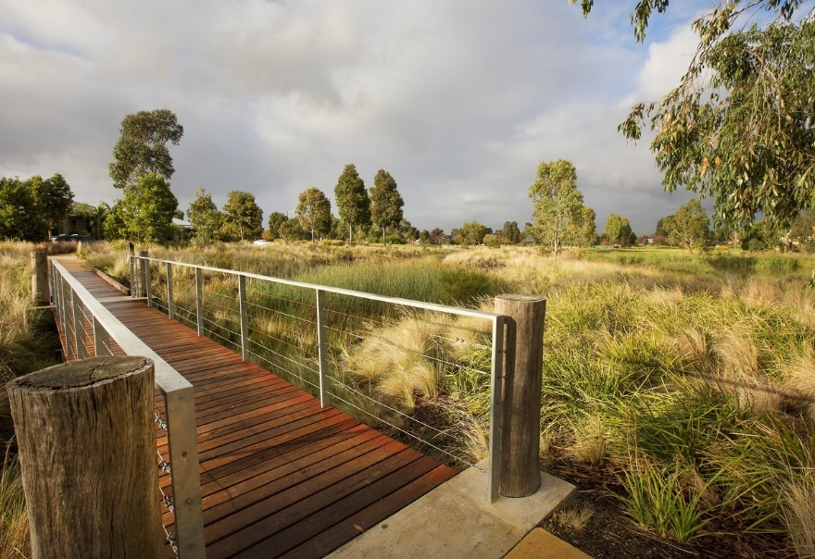
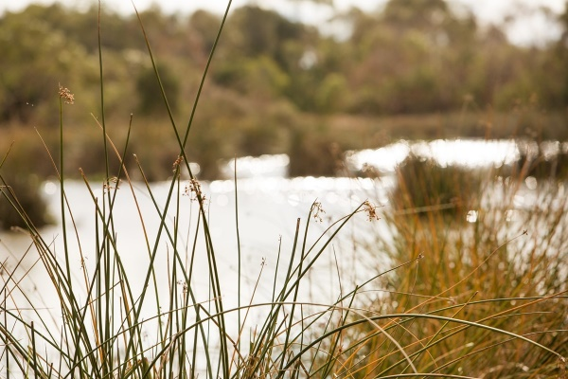
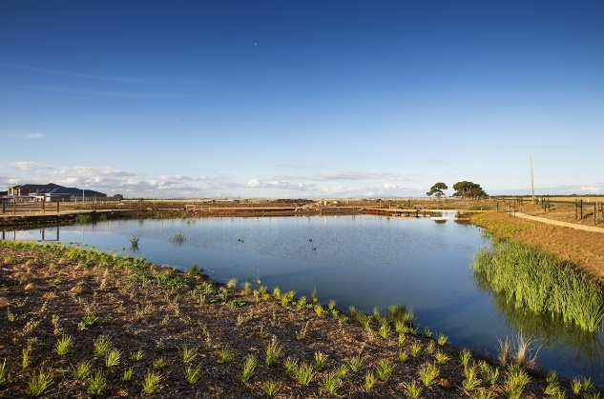
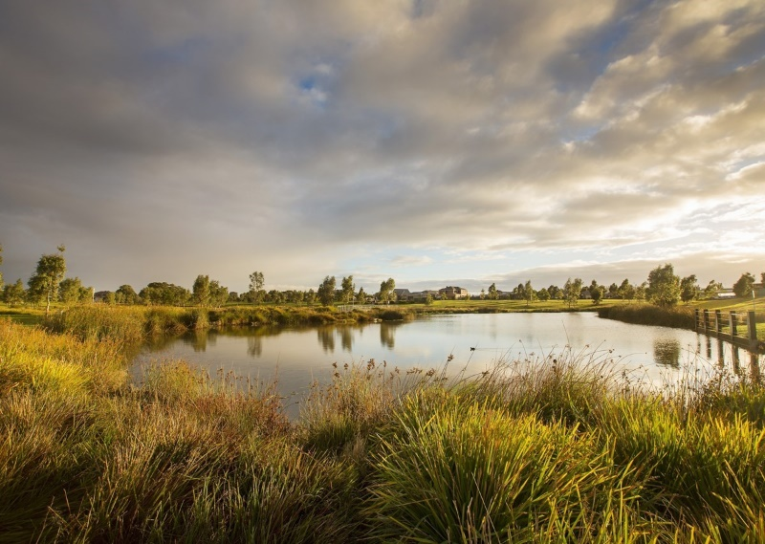
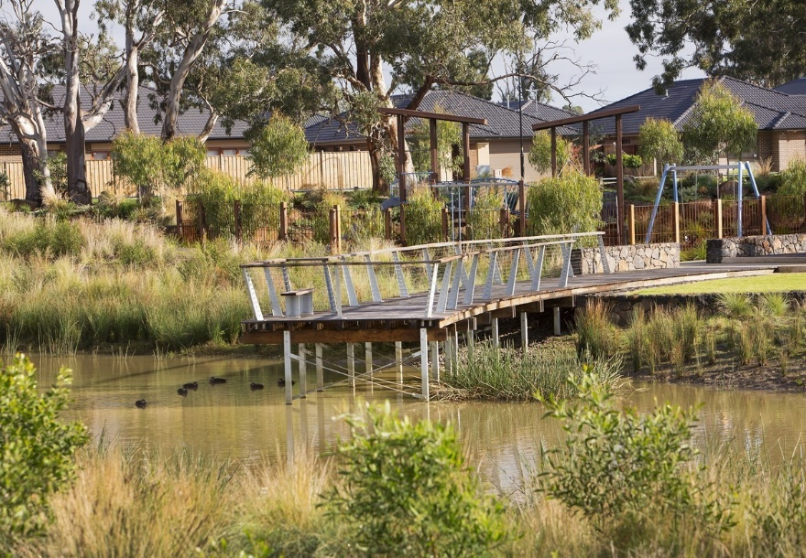

Appendix 1

Projects with Allocated status in Maximo DFWS module, and End Year between 21/22 and 25/26. Assumes projects will be completed as per End Year.

Start_Year | End_Year | SHAPE AREA (GIS Shape area) (Ha) | Status | Municipality | Project
2020 | 2022 | 4.86 | ALLC | CARDINIA | PDC4493
2018 | 2022 | 10.18 | ALLC | CASEY | PDC4510
2020 | 2022 | 0.80 | ALLC | CASEY | PDC4799
2020 | 2022 | 1.12 | ALLC | WYNDHAM | P18747
2020 | 2023 | 0.33 | ALLC | CASEY | P20984
2020 | 2023 | 1.42 | ALLC | CASEY | P20439
2020 | 2023 | 3.38 | ALLC | CASEY | PDC4690
2020 | 2023 | 3.24 | ALLC | CASEY | PDC4683
2022 | 2023 | 2.78 | ALLC | CASEY | PDC4667
2019 | 2023 | 0.88 | ALLC | HUME | P19548
2019 | 2023 | 0.38 | ALLC | HUME | P19548
2019 | 2023 | 0.35 | ALLC | HUME | P19548
2020 | 2023 | 0.33 | ALLC | HUME | PDC3989
2020 | 2023 | 0.15 | ALLC | HUME | P19517
2020 | 2023 | 0.23 | ALLC | HUME | P19517
2020 | 2023 | 0.22 | ALLC | HUME | P19517
2020 | 2023 | 5.85 | ALLC | HUME | P19532
2020 | 2023 | 11.98 | ALLC | KINGSTON | P18796
2020 | 2023 | 2.16 | ALLC | MELTON | P21353
2020 | 2023 | 2.14 | ALLC | MELTON | P20943
2020 | 2023 | 3.08 | ALLC | MELTON | P19019
2019 | 2023 | 1.63 | ALLC | WHITTLESEA | P19190
2021 | 2023 | 3.69 | ALLC | WYNDHAM | P22084
2021 | 2024 | 1.77 | ALLC | BAW BAW | P25095
2020 | 2024 | 1.24 | ALLC | CARDINIA | PDC4684
2021 | 2024 | 3.75 | ALLC | CASEY | P24551
2021 | 2024 | 0.46 | ALLC | CASEY | P23283
2021 | 2024 | 0.81 | ALLC | HUME | P23785
2021 | 2024 | 1.79 | ALLC | MELTON | P22815
2021 | 2024 | 1.70 | ALLC | WYNDHAM | P23519
2021 | 2024 | 2.96 | ALLC | WYNDHAM | P23513
2021 | 2025 | 2.23 | ALLC | <Null> | P26114
2020 | 2025 | 4.79 | ALLC | CASEY | PDC4425
2021 | 2025 | 0.26 | ALLC | CASEY | P25287
2021 | 2025 | 1.37 | ALLC | CASEY | P25389
2021 | 2025 | 1.45 | ALLC | MELTON | P25390
2021 | 2025 | 2.81 | ALLC | MELTON | P26143
2021 | 2025 | 2.50 | ALLC | MELTON | P25926
2020 | 2025 | 1.90 | ALLC | WHITTLESEA | PDC4175
2021 | 2025 | 3.33 | ALLC | WHITTLESEA | P26216
2021 | 2025 | 1.31 | ALLC | WYNDHAM | P25736
2021 | 2025 | 2.71 | ALLC | WYNDHAM | P25524
2020 | 2026 | 1.55 | ALLC | CARDINIA | PDC4598
2020 | 2026 | 4.54 | ALLC | CARDINIA | PDC2372
2020 | 2026 | 3.71 | ALLC | GREATER DANDENONG | PDC4125

Appendix 2

Projects with Future status in Maximo DFWS module, and Start Year between 20/21 and 23/24. Assumes projects will be completed 2 yrs after Start Year - no projects in the system prior to 20/21.

Start_Year | End_Year | SHAPE AREA (GIS Shape area) | Status | Municipality
2021 | 2023 | 7.31 | FUT | CARDINIA
2021 | 2024 | 14.27 | FUT | CASEY
2021 | 2026 | 3.25 | FUT | CASEY
2021 | 2026 | 0.50 | FUT | CASEY
2021 | 2026 | 1.05 | FUT | CASEY
2021 | 2023 | 5.31 | FUT | GREATER DANDENONG
2021 | 2024 | 1.32 | FUT | MACEDON RANGES
2021 | 2021 | 4.11 | FUT | WHITTLESEA
2021 | 2021 | 2.64 | FUT | WHITTLESEA
2021 | 2021 | 1.18 | FUT | WHITTLESEA
2021 | 2021 | 2.45 | FUT | WHITTLESEA
2021 | 2023 | 1.33 | FUT | WHITTLESEA
2021 | 2023 | 1.28 | FUT | WHITTLESEA
2021 | 2022 | 4.29 | FUT | WYNDHAM
2021 | 2023 | 5.58 | FUT | WYNDHAM
2021 | 2023 | 2.40 | FUT | WYNDHAM
2021 | 2025 | 4.46 | FUT | WYNDHAM
2021 | 2026 | 1.64 | FUT | WYNDHAM
2022 | 2026 | 1.01 | FUT | CASEY
2022 | 2026 | 16.26 | FUT | GREATER DANDENONG
2022 | 2024 | 0.14 | FUT | HUME
2022 | 2024 | 0.42 | FUT | HUME
2022 | 2024 | 1.19 | FUT | HUME
2022 | 2027 | 1.59 | FUT | MACEDON RANGES
2022 | 2027 | 0.85 | FUT | MACEDON RANGES
2022 | 2025 | 2.49 | FUT | MELTON
2022 | 2024 | 0.48 | FUT | NILLUMBIK
2022 | 2025 | 1.30 | FUT | WHITTLESEA
2022 | 2024 | 4.67 | FUT | WYNDHAM
2023 | 2026 | 4.87 | FUT | CARDINIA
2023 | 2028 | 4.27 | FUT | CARDINIA
2023 | 2026 | 1.51 | FUT | CASEY
2023 | 2027 | 1.66 | FUT | CASEY
2023 | 2028 | 3.08 | FUT | MELTON
2023 | 2025 | 1.67 | FUT | WHITTLESEA
2023 | 2025 | 3.92 | FUT | WYNDHAM
2024 | 2026 | 0.67 | FUT | BAW BAW
2024 | 2029 | 4.56 | FUT | CARDINIA
2024 | 2026 | 2.55 | FUT | MELTON
2024 | 2027 | 2.10 | FUT | MELTON
2024 | 2028 | 1.56 | FUT | MELTON
2024 | 2026 | 2.23 | FUT | WHITTLESEA
2024 | 2026 | 4.20 | FUT | WYNDHAM

