VEU Variation to Accreditation Conditions Form
  - Version 1.0 – 22 May 2024
Purpose of this form
This application form must be used when applying to the Essential Services Commission for a:
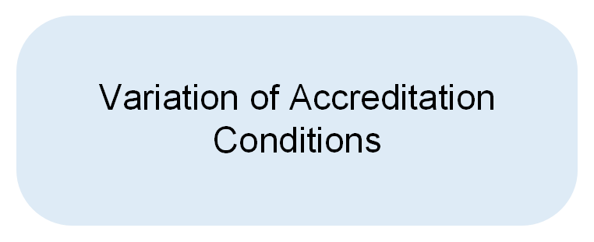

If you are applying for a grant of accreditation or renewal of accreditation, complete the appropriate form on our website.

Fees:
- $1500 to vary conditions of accreditation
Please Note:
- This form is for existing accredited persons who have successfully renewed their accreditation and new accredited persons from 1 July 2023 to apply to vary conditions of their accreditation.
- This form is to be completed by, or on behalf of a person or corporate body seeking to vary conditions of accreditation.
- This form must be signed by an officer of the Applicant, (as defined below), or if the Applicant is an individual, that individual.
- Answering "no" to a question on this form will not necessarily be grounds for refusal. It may prompt a request for information and further assessment. A false or misleading answer may have serious consequences, including refusal of the application.
- It is an offence to knowingly provide false or misleading information to the commission, under s68 of the Victorian Energy Efficiency Target Act 2007.

Instructions to apply for a variation of accreditation conditions
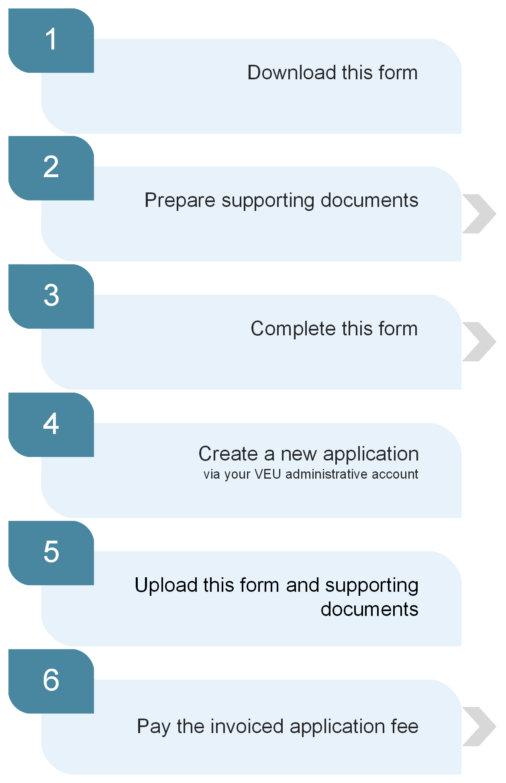
Follow the instructions on page 3 of this form explaining which sections
to complete

Refer to the Application Guide for a list of required documents

We will not begin processing an application until the relevant fee has been paid

Which sections of this form should you complete?
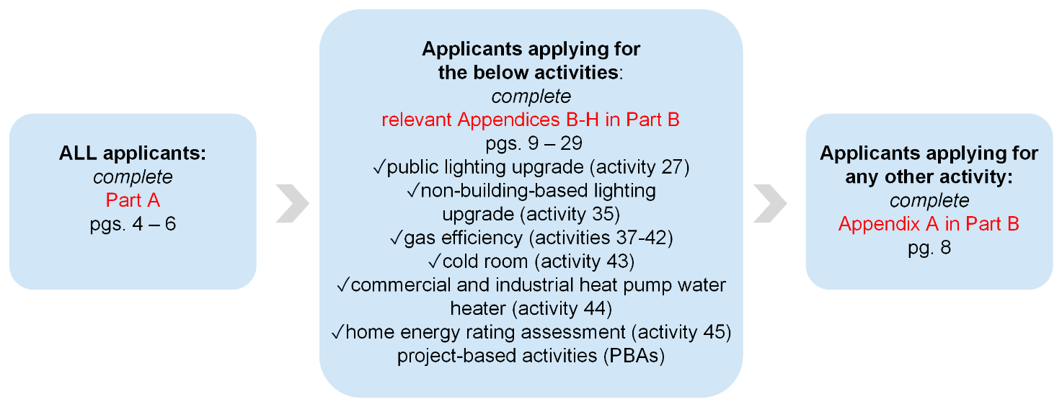

What happens next?
Once you have submitted a complete application form and paid the fee, the commission has 20 business days to process your application. This timeline is often extended either due to requests for further information or by agreement with the Applicant.
If approved, the commission will provide a written notice confirming the decision to approve your application. This notice will specify the commencement date of accreditation, the expiry date, and the deadline for the Applicant to apply for renewal. Additionally, it will outline the prescribed activities for which accreditation is granted.
If refused, the commission will issue a written notice regarding the decision to reject your application. You may request an internal review of a refusal decision.

Further Assistance
Refer to the Application Guide for Accredited Persons on our website for guidance on completing and lodging this form.
Contact the VEU Program support team if you have any questions about the application process via phone: (03) 9032 1310 or email: veu@esc.vic.gov.au

Part A – Variation of accreditation conditions
Defined terms used in this form
- “Applicant” means the individual or body corporate applying for accreditation or for renewal of accreditation.
- “officer(s) of the Applicant”, for an Applicant that is a body corporate, means all Directors and the Company Secretary of the Applicant and any person who makes or participates in making decisions that affect the whole of, or a substantial part of, the Applicant’s business, for example the Chief Executive Officer, the Chief Financial Officer, the Managing Director.

Person preparing this application
Q1. Name and job title of the person preparing this application
Click here to enter text.
Q2. Has a third party assisted the Applicant in preparing this application?
If yes, please provide that individual’s name and business name.
Click here to enter text.
Q3. Email address of the person preparing this application
Click here to enter text.
Q4. Contact phone number of the person preparing this application
Click here to enter text.

Applicant details
Q5. Full legal name of the Applicant
Click here to enter text.
Q6. Email address of the Applicant to be used by the commission
Click here to enter text.
Q7. ABN and/or ACN
ABN given by the Australian Business Register and/or ACN (if the Applicant is a body corporate) given by ASIC.
Click here to enter text.

Activities
When submitting the application in the registry, under Tab 1 of the online application select the additional activities the Applicant plans to undertake in the next 12 months.

Business model and prescribed activity delivery
Q8. How does the Applicant intend to deliver the additional activity/activities?
Click here to enter text.

Competence and capability requirements
Experience and qualifications
Q9. Describe the Applicant’s relevant experience in the industry/field relating to the prescribed activities for which certificates will be created.
- For example, if the Applicant is applying to undertake prescribed activities associated with water heating, describe the Applicant’s experience in the water heating industry. This may include describing the experience of relevant personnel in the organisation or any contracted third-party scheme participants providing services.
Click here to enter text.
Skills and licensing
Q10. Does the Applicant, its employees and/or contracted scheme participants have the appropriate licensing for undertaking the prescribed activities?
Select Yes or No from the dropdown box:
Choose an item.
Q11. Upload a document listing the relevant licence(s) of the Applicant’s staff that will undertake prescribed activities.
Include the licence number(s) and expiry date(s).
Document file name: | Click here to enter text.
Click here to enter text.

Additional documents to be supplied
Assignment form(s)
Q12. Provide a copy of the assignment forms for each prescribed activity which the Applicant is applying to be accredited.
For applications to undertake lighting upgrade activities (activities 27, 34 and 35), this includes copies of AS/NZS compliance declaration.
Document file names: | Click here to enter text.

Declaration
I declare that:
- I am authorised to submit this application to the Essential Services Commission (commission) on behalf of the Applicant; and
- To the best of my knowledge and belief, and having taken all reasonable steps to verify the information, that all the information in the form is true and correct as at the date of this declaration;
I understand that:
- It is an offence to give information and documentation to the commission that I know to be false or misleading in a material particular; and that
- Provision of incorrect, false or misleading information may result in the application for accreditation being refused.
Name: | Click here to enter text.
Signature:
Date: | Click or tap to enter a date.

Part B – VEU activity application
This section requires information that will assist the commission to ascertain if an Applicant is competent and capable to undertake the prescribed activities it is applying to undertake.
All Applicants are required to complete at least one of the activity specific forms provided in Part B depending on which activity/activities they are applying to be accredited for:
Appendix A: All activities (except those specific to Appendices B-H)
(Note: where applicable, a response is required to be provided for each activity)
Appendix B: Public lighting upgrade (Activity 27)
Appendix C: Non-building based lighting upgrades (Activity 35)
Appendix D: Gas efficiency related upgrades (Activities 37-42)
Appendix E: Cold room upgrades (Activity 43)
Appendix F: Commercial and industrial heat pump water heaters (Activity 44)
Appendix G: Home Energy Rating Assessment (HERA) upgrades
Appendix H: Project-based Activities (PBAs)
Applicants should refer to the Application Guide for Accredited Persons for further assistance
in completing and lodging this aspect of their application.

Appendix A: Competence and capability requirements – all activities (except those identified in Appendices B-H)
Eligibility
Q1. Upload a document that identifies the process that the Applicant and its scheme participants will follow to verify that an activity meets the eligibility requirements as set out in the regulations and VEU Specifications. A separate process should be provided for each of the prescribed activities the Applicant seeks to be accredited to undertake.
Document file name: | Click here to enter text.
Installation
Q2. Upload a document that identifies the process the Applicant and its scheme participants will follow to ensure that installations specific to each activity for which the Applicant is applying comply with all relevant VEU requirements.
Note: the process does not need to cover all technical aspects of conducting installations, but simply the steps taken to ensure compliance with program requirements is achieved.
Document file name: |  | Click here to enter text.
Decommissioning
Q3. Upload a copy of the step-by-step process that the Applicant and its scheme participants will follow to satisfy the decommissioning requirements specific to each activity that the Applicant intends to undertake. Explain how storage, collection, transport and deposit of decommissioned products will be conducted in accordance with the Environment Protection Act 2017.
Note: If none of the activities applied for require that a product be decommissioned, please record N/A in the field below.
Document file name: | Click here to enter text.

Appendix B: Public lighting upgrade (activity 27)

Applicant details
Applicant details
Q1. Is the Applicant a relevant body e.g., a distribution company, a Council or responsible road authority? Select Yes or No from the dropdown box.
Choose an item.
If yes, state the type of relevant body: | Click here to enter text.

Public lighting upgrade type
Organisational overview
Q2. Describe the type of public lighting upgrades the Applicant intends to undertake.
Click here to enter text.

Policies and procedures
Policies and procedures
Q3. Upload the Applicant’s policies and processes for completing public lighting upgrade activities which must include:
- The decommissioning and recycling of removed lighting equipment in accordance with the Environment Protection Act 2017 and regulations.
- How the Applicant will comply with waste management requirements under the Environment Protection Act 2017 and regulations.
- How the Applicant will ensure that the baseline environment for an installation has not been altered prior to the installation (i.e. products replaced as part of an installation were not installed for the purposes of being decommissioned as part of the installation).
- Data validation and quality assurance methods of public lighting upgrades.
Document file name: | Click here to enter text.

Standards
AS/NZS 1158
Q4. Upload a statement outlining how the Applicant’s systems incorporate the requirements of AS/NZS 1158.
The statement must specify if/when the Applicant’s lighting designs deviate from AS/NZS 1158, the justification for the deviation(s) in accordance with the standard, and how the Applicant sets out the reasons why the deviation(s) are justified.
Document file name: | Click here to enter text.

Documents to be supplied
AS/NZS 1158 compliance declaration
Q5. Upload a copy of the Applicant’s AS/NZS 1158 Compliance Declaration for Public Lighting Upgrade (Activity 27). The documents must be modelled on the relevant templates (available at www.esc.vic.gov.au/public-lighting).
Document file name: | Click here to enter text.

Appendix C: Non-building based lighting upgrade (activity 35)

Non-building based lighting upgrade type
Organisational overview
Q1. Describe the type(s) of non-building based lighting upgrades the Applicant intends to undertake:
Click here to enter text.

Policies and procedures
Policies and procedures
Q2. Upload a copy of the Applicant’s policies and procedures for non-building based lighting upgrade activities which must include:
  - The decommissioning and recycling of removed lighting equipment in accordance with the Environment Protection Act 2017 and regulations.
  - How the Applicant will comply with waste management requirements under the Environment Protection Act 2017 and regulations.
  - How the Applicant will ensure that the baseline environment for an installation has not been altered prior to the installation (i.e. products replaced as part of an installation were not installed for the purposes of being decommissioned as part of the installation).
  - Data validation and quality assurance methods of non-building based lighting upgrades.
Document file name: | Click here to enter text.

Quality and safety assurance
Quality and safety management systems
Q3. Describe the Applicant’s safety management procedures in relation to
non-building based lighting upgrade activities and explain how they comply with the Electricity Safety Act 1998, the Gas Safety Act 1997, the Occupational Health and Safety Act 2004, the Building Act 1993 and regulations made under those acts. Upload any relevant documentation below.
Describe how the Applicant will ensure that it, and any contractors, have relevant safety management systems in place for upgrades. Explain in the statement whether the Electricity Safety Act 1998, Gas Safety Act 1997 and/or Building Act 1993 are relevant to the Applicant’s proposed activities, and, if so, how the policies comply with those requirements.
Click here to enter text.
Document file name: | Click here to enter text.
Quality management
Q4. Is the Applicant ISO 9001 certified? Select Yes or No from the dropdown box.
Choose an item.
If yes – upload associated evidence:
Document file name: | Click here to enter text.
If no – confirm the following and upload associated evidence, such as documented quality policies, to demonstrate that the quality management systems align with the framework of ISO 9001 certification:
I declare that the quality management systems of the Applicant align with and satisfy the framework of ISO 9001 certification. |  | ☐
Document file name: | Click here to enter text.
Safety Management
Q5. Is the Applicant AS/NZS 4801 certified? Select Yes or No from the dropdown box.
Choose an item.
If yes – upload associated evidence:
Document file name: | Click here to enter text.
If no – confirm the following and upload associated evidence, such as documented safety policies, to demonstrate that the safety management systems align with the framework of AS/NZS 4801 certification:
I declare that the safety management systems of the Applicant align with and satisfy the framework of AS/NZS 4801. |  | ☐
Document file name: | Click here to enter text.
Q6. Does the Applicant have safe work methods that are in line with the compliance and risk profile of non-building based lighting upgrade activities (such as working at heights, operation of working at heights equipment, traffic and pedestrian management, working in close proximity to power lines etc.)? Select Yes or No from the dropdown box.
Choose an item.
If yes – upload associated evidence
Document file name: | Click here to enter text.

Standards and competencies
AS/NZS 1158 and AS 2560
Q7. Upload a statement outlining how the Applicant’s systems incorporate the requirements of AS/NZS 1158 and/or AS 2560.
Document file name: | Click here to enter text.
Training
Q8. Upload a document describing the Applicant’s training procedures specific to
non-building based lighting upgrades. The description must include the relevant training records of service delivery personnel and reference all required mandatory safety training (MST) regarding the following installation environments:
- Traffic management
- Working at heights
- Operation of EWP (scissor-type)
- Operation of EWP (boom-type, under 11 metres)
- Overhead utilities (power lines)
Document file name: | Click here to enter text.

Documents to be supplied
AS/NZS 1150 and/or AS 2560 compliance declaration(s)
Q11. Upload a copy of the Applicant’s AS/NZS 1150 and/or AS 2560 compliance declaration(s). The documents must be modelled on the relevant templates provided at www.esc.vic.gov.au/non-building-based-lighting.
Document file name: | Click here to enter text.

Appendix D: Gas efficiency activities (activities 37-42)

Gas efficiency activity type
Organisational overview
Q1. Describe the type(s) of gas efficiency activities the Applicant intends to undertake.
Click here to enter text.

Policies and procedures
Policies and procedures
Q2. Upload a copy of the Applicant’s policies and procedures for gas efficiency upgrade activities which must include:
- The decommissioning and recycling of removed equipment in accordance with the Environment Protection Act 2017 and regulations.
- How the Applicant will comply with waste management requirements under the Environment Protection Act 2017 and regulations.
- How the Applicant will ensure that the baseline environment for an installation has not been altered prior to the installation (i.e., products replaced as part of an installation were not installed for the purposes of being decommissioned as part of the installation).
- Data validation and quality assurance methods of gas efficiency upgrades.
Document file name: | Click here to enter text.
Safety Management
Q3. Describe the Applicant’s safety management procedures in relation to gas efficiency upgrade activities and explain how they comply with the Electricity Safety Act 1998, the Gas Safety Act 1997, the Occupational Health and Safety Act 2004, the Building Act 1993 and regulations made under those acts.
Describe how the Applicant will ensure that it, and any contractors have relevant safety management systems in place for upgrades. Explain in the statement whether the Electricity Safety Act 1998, Gas Safety Act 1997 and/or Building Act 1993 are relevant to the Applicant’s proposed activities, and, if so, how the policies comply with those requirements.
Click here to enter text.
Q4. Does the Applicant understand its obligations regarding occupational health and safety, specifically relating to the undertaking of gas efficiency related activities (refer to Applicant guide for further information)? Select Yes or No from the dropdown box.
Choose an item.

Standards and competencies
Minimum thermal efficiency requirements
Complete this section if the Applicant intends to undertake:
Activity 37: Gas-fired steam boiler and/or
Activity 38: Gas-fired hot water boiler or gas-fired water heater
Q5. Upload a statement outlining how the Applicant will ensure compliance with the minimum thermal efficiency requirements of activity 37 and/or activity 38 in accordance with the following available standards/methods:
- BS 845-2 (pre-commissioning), BS 845-1 (post-commissioning); or equivalent standard approved by the Essential Services Commission; or
- Commission Regulation (EU) No 813/2013; or
- The manufacturer’s technical specification for that product (for condensing boilers only).
To be complete, the statement must describe the process, or processes, the Applicant proposes to follow to meet the relevant standard.
Document file name: | Click here to enter text.

Document to be supplied
Mandatory insurance
Q6. To participate in gas efficiency activities in the VEU Program, in addition to the insurance requirements in Part A, the Applicant must have the required insurance coverage below:

- Where advice is given and followed, professional indemnity insurance of at least $5 million, covering the replacement and/or rectification of customers’ property damaged as a result of any advice provided by the accredited person.

Attach the Applicant’s insurance certificate of currency, if required.
Document file name: | Click here to enter text.

Appendix E: Cold room activities (activity 43)

1. Cold room activity type
Organisational overview
Q1. Describe the type of cold room upgrades the Applicant intends to undertake.
Click here to enter text.

2. Policies and procedures
Policies and procedures
Q2. Upload a copy of the Applicant’s policies and procedures for cold room upgrade activities which must include:
- The decommissioning and recycling of removed equipment in accordance with the Environment Protection Act 2017 and regulations, if required.
- How the Applicant will comply with waste management requirements under the Environment Protection Act 2017 and regulations.
- How the Applicant will ensure that the baseline environment for an installation has not been altered prior to the installation (i.e., products replaced as part of an installation were not installed for the purposes of being decommissioned as part of the installation).
- Data validation and quality assurance methods of cold room upgrades.
Document file name: | Click here to enter text.
Safety Management
Q3. Describe the Applicant’s safety management procedures in relation to
cold room upgrade activities and explain how they comply with the Electricity Safety Act 1998, the Gas Safety Act 1997, the Occupational Health and Safety Act 2004, the Building Act 1993 and regulations made under those acts.
Describe how the Applicant will ensure that it, and any contractors have relevant safety management systems in place for upgrades. Explain in the statement, whether the Electricity Safety Act 1998, Gas Safety Act 1997 and/or Building Act 1993 are relevant to the Applicant’s proposed activities, and, if so, how the policies comply with those requirements.
Click here to enter text.
Q4. Does the Applicant understand its obligations in relation to occupational health and safety specifically relating to the undertaking of cold room upgrade activities (refer to Applicant guide for further information)? Select Yes or No from the dropdown box.
Choose an item.

3. Standards and competencies
Compliance with AS/NZS 5149
Complete this section if the Applicant intends to undertake:
Activity 43: Cold room activity
Q5. Upload a statement outlining the Applicant’s understanding of AS/NZS 5149 Refrigerating Systems and Heat Pumps – Safety and Environmental Requirements.
To be complete, the statement must describe the process, or processes, the Applicant proposes to follow the relevant standard.
Document file name: | Click here to enter text.

4. Document to be supplied
Mandatory insurance
Q6. To participate in the cold room activity in the VEU Program, in addition to the insurance requirements in Part A, the Applicant must have the required insurance coverage below:
- Where advice is given and followed, professional indemnity insurance of at least $5 million, covering the replacement and/or rectification of customers’ property damaged as a result of any advice provided by the accredited person.
- Where the advice is being provided by a scheme participant, not the Applicant, the scheme participant will require insurance cover.
Attach the Applicant’s insurance certificate of currency, if required.
Document file name: | Click here to enter text.

Appendix F: Commercial and industrial water heater (activity 44)

1. Commercial and industrial water heater activity type
Organisational overview
Q1. Describe the type of commercial and industrial heat pump water heater upgrades the Applicant intends to undertake.
Click here to enter text.

2. Policies and procedures
Policies and procedures
Q2. Upload a copy of the Applicant’s policies and procedures for commercial and industrial heat pump water heater activities which must include:
- The decommissioning and recycling of removed equipment in accordance with the Environment Protection Act 2017 and regulations.
- How the Applicant will comply with waste management requirements under the Environment Protection Act 2017 and regulations.
- How the Applicant will ensure that the baseline environment for an installation has not been altered prior to the installation (i.e., products replaced as part of an installation were not installed for the purposes of being decommissioned as part of the installation).
- Data validation and quality assurance methods of commercial and industrial water heater upgrades.
Document file name: | Click here to enter text.
Safety management
Q3. Describe the Applicant’s safety management procedures in relation to
commercial and industrial heat pump water heater upgrades and explain how they comply with the Electricity Safety Act 1998, the Gas Safety Act 1997, the Occupational Health and Safety Act 2004, the Building Act 1993 and regulations made under those acts.
Describe how the Applicant will ensure that it, and any contractors have relevant safety management systems in place for upgrades. Explain in the statement, whether the Electricity Safety Act 1998, Gas Safety Act 1997 and/or Building Act 1993 are relevant to the Applicant’s proposed activities, and, if so, how the policies comply with those requirements
Click here to enter text.
Q4. Does the Applicant understand its obligations in relation to occupational health and safety specifically relating to the undertaking of commercial and industrial water heater related activities (refer to Applicant guide for further information)? Select Yes or No from the dropdown box.
Choose an item.

3. Standards and competencies
Compliance with AS/NZS 2712
Activity 44: commercial and industrial heat pump water heater
Q5. Upload a statement outlining the Applicant’s:
- Understanding of AS/NZS 2712 Solar and heat pump water heaters – Design and construction standard.
- Decommissioning procedures and processes to ensure the Applicant meets the legislative requirements for commercial and industrial heat pump water heater activity.
- Process, approach and/or systems to ensure that approved product/s are installed as modelled in TRNSYS.
To be complete, the statement must describe the process, or processes, the Applicant proposes to follow the relevant standard.
Document file name: | Click here to enter text.

4. Document to be supplied
Mandatory insurance
Q6. To participate in the commercial and industrial heat pump water heater activity in the VEU Program, in addition to the insurance requirements in Part A, the Applicant must have the required insurance coverage below:
- Where advice is given and followed, professional indemnity insurance of at least $5 million, covering the replacement and/or rectification of customers’ property damaged as a result of any advice provided by the accredited person.
- Where the advice is being provided by a scheme participant, not the accredited person, the scheme participant will require insurance cover.
Attach the Applicant’s insurance certificate of currency, if required.
Document file name: | Click here to enter text.

Appendix G: Home energy rating assessment (HERA) activities

1. Service delivery arrangements (specific to HERA activities)
Service delivery arrangements
Q1. Identify the nature of the commercial relationship between the Applicant and the Scorecard assessors who will be performing VEU home energy rating assessments.
Select the applicable box:
☐ The Applicant is the Scorecard assessor.
☐ The Applicant will employ Scorecard assessors.
☐ The Applicant will contract the services of Scorecard assessors.
☐ Scorecard assessors will be financially incentivised to identify prescribed activities that will be delivered by the Applicant.
☐ Other, please specify:
Click here to enter text.
Q2. Upload a copy of any template contract that you intend to use, in the engagement of Scorecard assessors.
Document file name: | Click here to enter text.

2. Policies and procedures
Policies and procedures
Q3. Upload a copy of the Applicant’s policies and procedures to ensure compliance with Victorian Energy Efficiency Target Regulations 2018 (VEET Regulations) and Victorian Energy Upgrades Specifications 2018 (VEU Specifications) for the home energy rating assessment activity. To be complete, the statement must include policies and procedures to address how you will:
- Determine the eligibility of an energy consumer’s premises.
- Contract and manage the accredited Scorecard assessors.
- Perform quality assurance checks of Scorecard information prior to submitting activities for VEEC creation.
Document file name: | Click here to enter text.
Q4. Upload a copy of the Applicant’s policies and procedures to record, store and manage consumer information in accordance with privacy protocols (i.e., managing consumer data in line with consumer consent in the VEEC assignment form and Scorecard privacy and conflict of interest statement form).
Document file name: |  | Click here to enter text.

3. Document to be supplied
Mandatory insurance
Q5. Upload a copy of the Applicant’s certificate of currency, showing:
- insured party details
- insured party policy details
- period of coverage
- maximum amount that the policy covers.

Note: To participate in the home energy rating assessment activity in the VEU Program, you must have the required insurance coverage:
- Public liability insurance cover of at least $5 million
- Products liability insurance cover of at least $5 million (covering the replacement and/or rectification of customers' property damaged as a result of work performed by the accredited person)
- Where advice is given and followed, professional indemnity insurance of at least $5 million, covering the replacement and/or rectification of customers’ property damaged as a result of any advice provided by the accredited person.
Document file name: | Click here to enter text.

Appendix H: Project-Based Activities (PBA)

Scope of potential projects
Scope of potential projects
Q1. Once accredited, how many VEU Program PBA projects does the Applicant intend to carry out each year?
Click here to enter text.
Q2. Which PBA methods does the Applicant intend to calculate VEECs with? Please tick the boxes below as appropriate.
☐ Measurement and verification
☐ Benchmark rating
Q3. What types of technologies would be used for the intended PBA project(s)?
Include how long have they been available in the Australian market.
Click here to enter text.
Q4. What regulatory/government approvals are needed for this technology to be used in Victoria?
Click here to enter text.
Q5. What other VEU Program activities could this project be achieved under?
e.g. none / Activity 34 / all.
Click here to enter text.
Q6. What is the motivation for using PBA instead of other activities?
Describe why the Applicant intends to use PBAs, rather than activities 1 to 42, to create VEECs.
Click here to enter text.
Implementation model
Q7. What is the Applicant’s intended implementation model specific to undertaking PBAs?
Provide a detailed statement that describes how the Applicant intends to create VEECs under PBA. The statement must explain how all aspects of a PBA project will be undertaken, including who will be engaging with the energy consumer, who will be undertaking work for the purposes of the project and any commercial arrangements between the Applicant and other relevant parties.
Click here to enter text.

Quality and safety assurance
Quality management
Q8. Is the Applicant ISO 9001 certified? Select Yes or No from the dropdown box.
Choose an item.
If yes – upload certificate
Document file name: |  | Click here to enter text.
If no – complete declaration below and upload associated evidence, such as documented quality policies, to demonstrate that the quality management systems align with the framework of ISO 9001 certification.
I declare that the Applicant’s quality management systems align with and satisfy the framework of ISO 9001 certification. I have uploaded quality management system documents. Select Yes or No from the dropdown box.
Choose an item.
Uploaded certificate or quality management system file name(s): | Click here to enter text.
Q9. Do the Applicant’s quality management procedures ensure the accuracy of VEEC calculations? Select Yes or No from the dropdown box.
Choose an item.
Q10. Provide a statement of the intended approach to ensuring the quality of evidence to support the accuracy of the calculated energy savings. Where the upgrade is not directly undertaken by the organisation, please outline how the Applicant will ensure that contractors will have relevant quality management systems in place.
Click here to enter text.
Safety Management systems
Q11. Describe the Applicant’s safety management procedures in relation to
project based activities and explain how they comply with the Electricity Safety Act 1998, the Gas Safety Act 1997, the Occupational Health and Safety Act 2004, the Building Act 1993 and regulations made under those acts.
Describe how the Applicant will ensure that it, and any contractors have relevant safety management systems in place for upgrades. Explain in the statement, whether the Electricity Safety Act 1998, Gas Safety Act 1997 and/or Building Act 1993 are relevant to the Applicant’s proposed activities, and, if so, how the policies comply with those requirements.
Click here to enter text.
Q12. Is the Applicant AS/NZS 4801 certified? Select Yes or No from the dropdown box.
Choose an item.
If yes – upload certificate
Document file name: |  | Click here to enter text.
If no – complete the declaration below and upload associated evidence, such as documented safety policies, to demonstrate that the safety management systems align with the framework of AS/NZS 4801 certification.
I declare that the Applicant’s safety management systems align with and satisfy the framework of AS/NZS 4801 certification. I have uploaded safety management system documents. Select Yes or No from the dropdown box.
Choose an item.
Uploaded certificate or safety management system file name(s): | Click here to enter text.
Q13. Does the Applicant have safe work methods that are in line with the compliance and risk profile for undertaking PBAs? Select Yes or No from the dropdown box.
Choose an item.

Document to be supplied
Mandatory insurance
Q14. To participate in PBAs under the VEU Program, in addition to the insurance requirements in Part A, the Applicant must have the required insurance coverage below:
- Where advice is given and followed, professional indemnity insurance covering the replacement and/or rectification of customers’ property damaged as a result of any advice provided by the AP.
Document file name: |  | Click here to enter text.
Q15. If the Applicant is applying to be an AP who intends to carry out a project at its own site, it is exempt from the mandatory requirements. In this case, please upload a signed ‘Insurance waiver declaration – project-based activities’ form. APs acting on their own site are responsible for assessing their own insurance needs; the commission does not mandate them.
All APs should consider the need for professional indemnity insurance for any experts they contract to provide advice on PBA.
Document file name: | Click here to enter text.
The certificate of currency is valid until: |  |  | Click or tap to enter a date.

4. Declaration
Declaration
I certify that the above details are correct at the time of completing this form and that I am authorised to act on behalf of the above account.
I have read and understood the information and requirements, relevant to the PBA method I intend to use to calculate VEECs, set out in the following guidance documents:
- Measurement and Verification Method Activity Guide
- Measurement and Verification Method Compliance Requirements
- Benchmark Rating Method Activity Guide
- Benchmark Rating Method Compliance Requirements
I consent to the provision of the following information to the administrators of greenhouse gas abatement schemes/energy efficiency schemes/emissions reduction schemes:
- Information on my account’s VEU accreditation, including approved activities covered by the accreditation.
- Information relating to activities undertaken once accredited under the VEU Program.
- Information relating to Victorian energy efficiency certificates created under this VEU accreditation for any period(s) requested by the administrator.
- Information concerning compliance with the requirements of the VEU Program, including the VEU code of conduct and matters pertaining to my account’s risk profile under the scheme.
- Information relating to any enforcement actions which may be taken against my account by the Essential Services Commission under the VEU Program.
I approve the publication of my name/company name and registration number in the Register of Accredited Persons upon accreditation approval which is publicly available via the VEU Registry.
I am aware that any lighting equipment removed during the project must be decommissioned safely and appropriately, and any new or replacement lighting equipment must be a product already approved by the Register of Products.
I know that all PBA activities must be undertaken in accordance with all the laws, regulations and codes of practice applicable to that activity.
I know that I must assess all relevant PBA project risks and will have appropriate safe work methods and other systems in place to manage those risks.
I acknowledge that penalties may be applied for providing misleading information under section 68 of the Victorian Energy Efficiency Target Act 2007.
Name: | Click here to enter text.
Signature:
Date: | Click or tap to enter a date.

