Minimum Electricity Feed-in Tariffs from 1 July 2025

Draft Decision

10 January 2025

## Acknowledgement

We acknowledge the Traditional Owners of the lands and waterways on which we work and live.

We acknowledge all Aboriginal and Torres Strait Islander communities and pay our respects to Elders past and present.

As the First Peoples of this land, belonging to the world’s oldest living cultures, we recognise and value their knowledge, and ongoing role in shaping and enriching the story of Victoria.

**An appropriate citation for this paper is:**

Essential Services Commission 2025, *Minimum Electricity Feed-in Tariffs from 1 July 2025: Draft Decision, 10 January*

© Essential Services Commission, 2025

[](http://creativecommons.org/licenses/by/4.0/)

This work Minimum Electricity Feed-in Tariffs from 1 July 2025: Draft Decision, 10 January, is licensed under a Creative Commons Attribution 4.0 licence [creativecommons.org/licenses/by/4.0]. You are free to re-use the work under that licence, on the condition that you credit the Essential Services Commission as author, indicate if changes were made and comply with the other licence terms.

The licence does not apply to any brand logo, images or photographs within the publication.

# 

Contents

Acknowledgement 1

Summary 3

The feed-in tariff is paid to customers for their electricity exports 5

We must consider certain costs in setting the minimum feed-in tariffs 6

We have maintained our approach in setting feed-in tariffs 7

Avoided costs approach 7

Alternative approaches 8

Feed-in tariffs are forecast to decrease 9

Solar-weighted wholesale prices drive the change in the feed-in tariffs 9

Solar-weighted wholesale prices are decreasing 10

Other avoided energy costs 12

We consider carbon and human health costs 13

Social cost of carbon 13

Human health costs 13

Households can save more by using the solar electricity they produce 14

What is the future of the minimum feed-in tariff? 15

The feed-in tariff is unlikely to increase 16

The minimum feed-in tariff cannot be negative 16

Next steps 16

How to provide feedback 16

Summary

* The draft minimum flat feed-in tariff is 0.04 cents per kWh starting 1 July 2025.
* The draft minimum time-varying feed-in tariffs will range from 0.0 to 7.5 cents per kWh starting 1 July 2025.
* This is lower than previous years due to an abundance of solar electricity generated during the day. This indicates that market forces are driving this change.
* In setting the minimum feed-in tariffs to apply from 1 July 2025, we must have regard to the wholesale electricity costs of solar exports; avoided costs faced by electricity retailers; the social cost of carbon; and human health costs as outlined in the *Electricity Industry Act 2000*.[1]
* The number of solar installations has increased significantly from around 446,000 in 2019 to around 787,000 by 30 November 2024.[2] This has been part of the Victorian community’s effort to reduce its carbon emissions and increase renewable energy generation. This has increased supply while demand is lower, resulting in the decreasing value of solar exports during the day since the introduction of feed-in tariffs.
* It is important to note that even though the feed in tariff is lower than previous years, any electricity used in the home from the household’s solar electricity is ‘free’ as customers avoid paying retail electricity prices.
* For a customer on the Victorian Default Offer, the retail price ranges from approximately 26 to 35 cents per kWh, depending on their distribution zone[3] – these are the actual costs that solar customers avoid.
* Households can maximise their savings by shifting their electricity usage to daylight hours – when their solar system is producing electricity. By doing this, households are not paid feed-in tariffs but avoid higher retail prices.
* Under the *Electricity Industry Act 2000*, the feed-in tariff cannot be set below zero. This means that retailers cannot charge their customers for their solar exports[4]
* The Essential Services Commission will make a final decision by 28 February 2025. For the final decision, we will use market data taken up to 17 January 2025.

The feed-in tariff is paid to customers for their electricity exports

Electricity retailers pay the feed-in tariff to customers for their electricity exports. Electricity retailers with a minimum of 5,000 customers must pay eligible customers at least the minimum feed-in tariff when those customers export electricity into the grid.

**What is a feed-in tariff?**

Feed-in tariffs are credits paid to customers with qualifying solar systems for electricity they export to the grid. Solar customers export electricity after their system usage meets all household consumption needs. Electricity retailers bill their customers for their electricity use on a net basis. This means customers receive the feed-in tariff for each kWh they export and pay the retail price for each kWh they import.

**While the Essential Services Commission sets the minimum feed-in tariffs, it is the retailers themselves who set the feed-in tariffs they pay their customers. This means that even when the feed-in tariffs are zero or close to it, some retailers may offer a feed-in tariff higher than the minimum.**

Solar customers are eligible for the minimum feed-in tariff if they have a renewable generation facility with a capacity of less than 100 kilowatts, with total output at the connection point of less than 30 megawatts.[5] This represents most household solar systems in Victoria.

Some commercial businesses will also receive the feed-in tariff, where the capacity of their system, and the amount it produces are within the above limits.

We must consider certain costs in setting the minimum feed-in tariffs

Victoria is the only jurisdiction in Australia that sets a minimum feed-in tariff. On or before 28 February each year, the Essential Services Commission must set one or more minimum rates for the electricity solar customers export to the grid to apply from 1 July.[6]

The *Electricity Industry Act 2000* lists the factors we must have regard to when setting a minimum feed-in tariff:

* + prices in the wholesale electricity market
  + avoided transmission and distribution losses
  + the avoided social cost of carbon and human health costs attributable to a reduction in air pollution.[7]

In setting the minimum feed in tariff, the commission also has regard to its objective as provided for in the *Essential Services Commission Act* *2001*, to promote the long-term interests of Victorian consumers.[8]

This review sets two kinds of tariffs:

* + a flat (constant anytime) feed-in tariff.
  + time varying feed-in tariffs (with two options available).

Electricity retailers can choose which of these they offer. Customers can only be on one of these tariffs at a given time, not a mixture (hybrid) of both.

An electricity retailer may develop their own feed-in tariff structures. However, they must also offer at least one of the minimum feed-in tariffs set by us. Electricity retailers cannot mix the blocks and prices of the time varying feed-in tariffs.

Electricity retailers can pay customers more than the minimum feed-in tariff we set, but they cannot pay less.

We have maintained our approach in setting feed-in tariffs

In setting the draft minimum feed-in tariffs to apply from 1 July 2025, we propose to continue using an ‘avoided cost’ methodology, consistent with our previous tariff reviews.

#### Data collection

We received half-hourly solar export data for the 2023–24 financial year from Victoria’s five electricity distribution businesses. We then forecasted the solar-weighted wholesale electricity price using the solar export data, along with historic wholesale electricity prices and futures prices.

#### Wholesale electricity data

We collected the corresponding historic wholesale electricity prices from the Australian Energy Market Operator. We gathered the wholesale electricity futures prices from ASX Energy. We used the wholesale electricity futures prices as they reflect price expectations for the next twelve months, which is the period in which the feed-in tariffs will apply.

Frontier Economics then used this information to forecast the wholesale electricity prices. They provide more information on their methodology in their report.[9]

This approach uses actual electricity market trends with external oversight to confirm the methodology is appropriate.

Avoided costs approach

This approach forecasts the value of the solar exports using the costs retailers avoid when purchasing customers’ exports and adding the value of avoided environmental costs. Electricity retailers avoid some costs when they buy electricity from solar customers. These include:

* + the price of wholesale electricity
  + network losses
  + market fees.

We use these to set the minimum feed-in tariff (along with the environmental and social value of solar).

The wholesale electricity price is the biggest driver of the change in feed-in tariff. It is the forecast of the wholesale electricity prices for when most solar exports happen. The avoided costs approach assigns a value to the wholesale electricity costs that solar exports enable electricity retailers to avoid.

### Alternative approaches

We weighed up alternative approaches to forecasting wholesale electricity prices as part of this review:

* + The first was to remove extreme market events and outliers from the wholesale forecasts.
  + The second approach averaged the wholesale electricity prices over three years.

Frontier Economics provided more details on these alternatives in their report.[10] However, neither of these approaches make any significant difference to the minimum feed-in tariff outcomes. As daytime wholesale electricity prices continue to decline, the flat, and daytime feed-in tariffs will also fall.

Feed-in tariffs are forecast to decrease

Our draft decision on the flat minimum feed-in tariff for 2025–26 is 0.04 cents per kWh. The flat minimum feed-in tariff for 2024–25 was 3.3 cents per kWh. Our draft decision on the time varying minimum feed-in tariffs is also lower than last year. These tariffs are set out in table 1.

Table 1: Minimum feed-in tariffs to apply from 1 July 2025, excluding GST**[11]**

|  |  |  |
| --- | --- | --- |
| **Flat minimum rate (cents/kWh)** | | |
| **At all times** | | |
| **0.04** | | |
| **Time-varying minimum rates (cents/kWh)** | | |
| **Option one** | | |
| **Overnight** | **Day** | **Early evening** |
| Weekdays: 10 pm – 7 am | Weekdays: 7 am – 3 pm,  9 pm – 10 pm | Weekdays: 3 pm – 9 pm |
| Weekends: 10 pm – 7 am | Weekends: 7 am – 10 pm | Weekends: n/a |
| **7.52** | **0.00** | **5.85** |
| **Option two** | | |
| **Shoulder** | **Off-peak** | **Peak** |
| Every day: 9 pm – 10 am,  2 pm – 4 pm | Every day: 10 am – 2 pm | Every day: 4 pm – 9 pm |
| **1.40** | **0.00** | **6.50** |

Note: The *Electricity Industry Act 2000* does not allow minimum feed-in tariffs to be less than zero cents/kWh. Therefore, where our forecast is less than zero, the minimum feed-in tariff is set to zero cents/kWh.

Solar-weighted wholesale prices drive the change in the feed-in tariffs

Electricity retailers incur costs when purchasing electricity from the National Electricity Market to meet their customers’ electricity demand. When an electricity retailer sources electricity from its solar customers (that is, exports) rather than the National Electricity Market, it avoids these costs.

The minimum feed-in tariffs represent these avoided costs. As the majority of solar exports take place between 11 am and 1 pm[12], the wholesale electricity prices at these times have the greatest weight in our forecast. This occurs because we use a solar-weighted average approach in our calculation.

In contrast, the wholesale prices that have a lower impact on the feed-in tariff calculations are when there are less solar exports.[13] Therefore, retailers do not pay solar customers the wholesale spot price when they are not exporting electricity to the grid. This helps the minimum feed-in tariffs reflect the value of solar electricity exports. Retailers are paying the price they actually face in the wholesale market when solar customers export (that is, supply) electricity to the grid.

This approach is consistent with how other generators – renewable or fossil fuel – operate in the National Electricity Market.

Figure 1 shows how the wholesale electricity price varies throughout the day. This figure indicates that peak solar exports occur between 11 am and 1 pm. This is also when the wholesale electricity price is at its lowest.

Solar-weighted wholesale prices are decreasing

We have estimated the wholesale electricity costs for the flat minimum feed-in tariff to be negative 2.4 c/kWh (–2.4), which is 3.0 c/kWh lower than last year when the forecast was 0.64 c/kWh. This reflects the lower daytime wholesale prices.

The wholesale spot price is set by supply and demand of electricity. When demand is low and supply is high and increasing, generators receive a lower price for the electricity they sell to the grid. The total solar installations have decreased demand for electricity from the grid, so that demand and therefore price, is lowest in the middle of the day.

Figure 1: Average actual solar-weighted prices

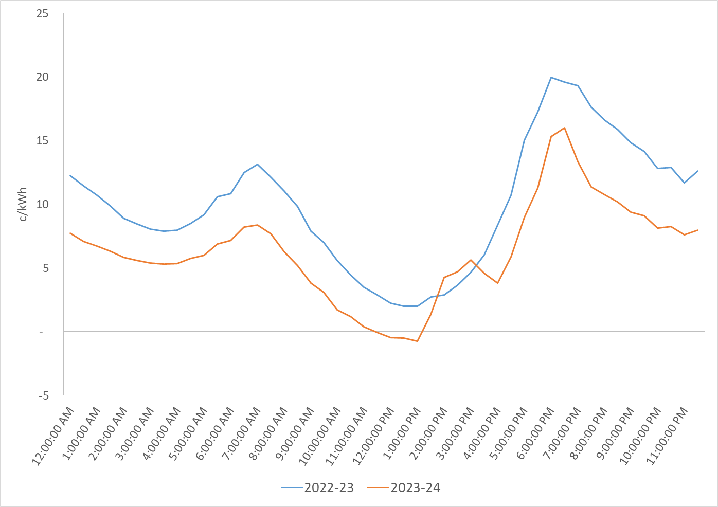

Source: Australian Energy Market Operator; Victorian distribution businesses; Essential Services Commission analysis.

The changes in Figures 1 and 2 illustrate how increases in solar exports have reduced the wholesale electricity price in the middle of the day. In contrast, wholesale electricity prices are much higher in the early morning, and from early evening into the night when solar exports are low. This means that wholesale electricity market retailers are buying small volumes of lower-priced daytime electricity (over four hours) and larger quantities of high-priced morning, evening, and overnight electricity (about 20 hours).

The average wholesale electricity price reflects this overall balance of daytime and evening/overnight prices and demand.

Figure 2: Average solar exports across the day

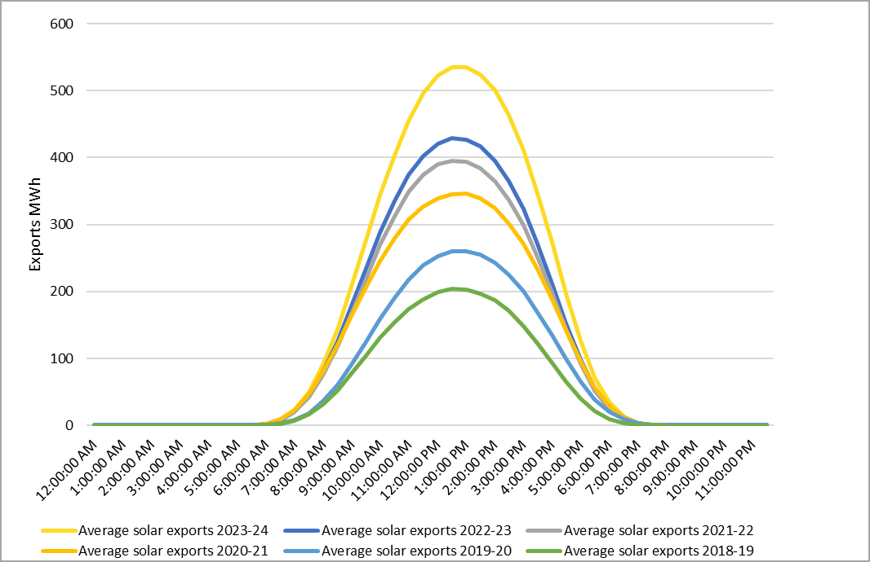

Source: Victorian distribution businesses; Essential Services Commission analysis.

Other avoided energy costs

We have estimated the other energy costs to be negative 0.08 c/kWh (–0.08), which is 0.21 c/kWh lower than last year.

Avoided line losses, market fees, and ancillary charges are a minor component of the feed-in tariff that we must have regard to. These components are usually positive, but for this draft decision, the negative value of the line losses outweighs the positive value of the market fees and ancillary service charges.

The value of the line losses are negative as we calculate this by multiplying our forecast wholesale electricity price by line losses factor. Because our forecast for wholesale price is negative, this means the value of line losses are also negative. See our previous decision for more information about how we set these cost components.[14]

We consider carbon and human health costs

We have used a value of 2.49 cents per kWh for the avoided social cost of carbon, as specified in the February 2017 Order in Council. This is consistent with the approach in past reviews. We maintain the standalone avoided human health costs at 0 cents per kWh.[15]

### Social cost of carbon

Emissions released during gas or coal-fired generation impose an economic cost on society by contributing to the greenhouse effect. We refer to this cost as the ‘cost of carbon’.

Along with carbon, fossil fuel generation is associated with air pollution (such as particulate matter) which can have a negative impact on human health. It follows that solar customers help avoid some of this air pollution when their solar electricity enters the grid instead of electricity from fossil fuel sources.

### Human health costs

The human health costs are the estimated health costs of air pollution (such as particulate matter) associated with fossil fuel powered electricity generation. Consistent with our previous decisions, we have not given a standalone valuation of the avoided human health costs. This reflects the fact that there is potential overlap between the social cost of carbon and human health costs.

Households can save more by using the solar electricity they produce

Although the minimum feed-in tariffs are declining, solar customers continue to benefit from their solar systems by using the free electricity that they generate.

When customers use this electricity, they avoid buying electricity from their retailer and therefore paying retail rates. Depending on their electricity distributor, a solar customer on the Victorian Default Offer could avoid retail tariffs of between approximately 26 cents and 35 cents per kWh through solar self-consumption.

St Vincent de Paul Society’s Victoria Energy Prices July 2024 (Victorian Tariff-Tracking Project update report[16]) illustrates potential financial benefits to households with solar versus non-solar. This report finds that new solar customers with a 3kW system installed will have an annual bill that is between $655 and $895 less (depending on network area) than non-solar customers with the same consumption level.

Solar customers can achieve additional savings on their electricity bills by shifting their electricity usage to daylight hours when their solar system is producing energy (for example, shifting hot water heating to the day).

What is the future of the minimum feed-in tariff?

The declining trend in feed-in tariff is unlikely to change in the future due to the increased uptake of solar systems by customers. There were approximately 446,000 household solar systems installed in Victoria in 2019.[17] This has increased substantially to 787,000 systems installed in November 2024.[18]

Since 2019–2020, the flat minimum feed-in tariff has been falling (see Figure 4). The draft decision forecasts this pattern to continue in 2025–26.

Figure 4 Flat minimum feed-in tariffs over time

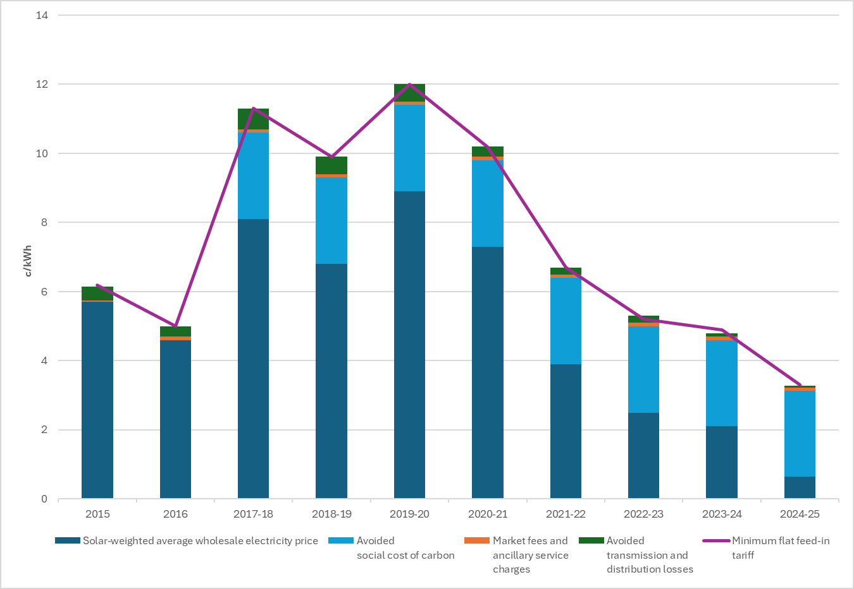

### The feed-in tariff is unlikely to increase

The increase in solar exports has reduced the wholesale electricity price in the middle of the day (see Figures 1 and 2). This trend means that the wholesale electricity prices in the middle of the day will keep falling and therefore the feed-in tariff, set using the avoided cost methodology, will keep falling.

There would need to be a significant event in the wholesale electricity market to reverse this outcome. For instance, the minimum feed-in tariffs continued to decline despite the upheaval in the wholesale electricity market in 2022. While the market experienced significant increases in wholesale electricity prices overall, daytime wholesale electricity prices continued to fall.

The minimum feed-in tariff cannot be negative

The Essential Services Commission determines the minimum rates to apply from 1 July[19] for the electricity solar customers export to the grid in accordance with the *Electricity Industry Act 2000*. As provided for in the *Electricity Industry Act 2000*, we may determine one or more minimum rates that a retailer must credit against the charges payable for the electricity that solar customers export to the grid. This minimum rate cannot be set at a negative amount (that is, an amount less than zero). A negative feed-in tariff would mean that solar customers may have to pay their retailer to export to the grid.

Next steps

We will release the final decision for the minimum feed-in tariff to apply from 1 July 2025 in February 2025. The final decision will use the latest data for the wholesale electricity price forecasts and the other factors we must consider. The final decision will also have regard to stakeholder submissions.

How to provide feedback

We welcome any feedback on our draft decision from households, small businesses, solar advocacy groups, electricity distribution businesses and retailers. Please send written submissions by close of business 31 January to either:

* Engage Victoria at  <https://engage.vic.gov.au/project/minimum-feed-in-tariff-review-202526>
* Email at [fitreview@esc.vic.gov.au](mailto:fitreview@esc.vic.gov.au)

We may not be able to consider suggestions made in submissions received after this date due to our obligation to publish the final decision by 28 February 2025.

Table 2 Review timeline

|  |  |
| --- | --- |
| Review milestone | Date |
| Submissions on draft decision due | 31 January 2025 |
| Final decision and determination | By 28 February 2025 |
| Minimum feed-in tariff 2025–26 takes effect | 1 July 2025 |

**Sensitive or confidential information**

We will publish submissions on our website, except for any information that is commercially sensitive or confidential. Submissions should clearly identify which information is sensitive or confidential.

1. *Electricity Industry Act 2000*, s. 40FBB(2)(a) and *Electricity Industry Act 2000*, s. 40FBB(3)(a)(b), and (c).
2. Clean Energy Regulator, [Postcode data for small scale installations](https://cer.gov.au/markets/reports-and-data/small-scale-installation-postcode-data) – accessed 17 December 2024, and ESC analysis.
3. Essential Services Commission, Victorian Default Offer prices to apply from 1 July 2024 to 30 June 2025, [Victorian Default Offer price review 2024–25 | Essential Services Commission](https://www.esc.vic.gov.au/electricity-and-gas/prices-tariffs-and-benchmarks/victorian-default-offer/victorian-default-offer-price-review-2024-25), flat tariffs for general usage-residential customers. The lowest rate is in the CitiPower distribution zone, and the highest rate is in the AusNet distribution zone as Block 1 rate. Accessed 11 December 2024.
4. The *Electricity Industry Act 2000* regulates the minimum feed-in tariffs that retailers must pay their customers, but it does not cover the tariffs a distribution business can charge retailers.
5. *Electricity Industry Act 2000*, s. 40F(1) and clause 13(1) of the General Exemption Order 2017 (as amended) made under s. 17 of the *Electricity Industry Act 2000.*
6. *Electricity Industry Act 2000*, s. 40FBB(2)(a).
7. *Electricity Industry Act 2000*, s. 40FBB(3)(a)(b) and (c).
8. *Essential Services Commission Act 2001*, s. 8.
9. Frontier Economics, Wholesale price forecasts for calculating minimum feed-in tariff: Final report for the Essential Services Commission, January 2025
10. Frontier Economics, Wholesale price forecasts for calculating minimum feed-in tariff: Final report for the Essential Services Commission, January 2025, Chapter 5.
11. The Option one tariff periods reflect arrangements in older time-varying network tariffs. The periods were set in an Order in Council: [*Victoria Government Gazette*, No S 216, 19 June 2013, Advanced Metering Infrastructure (AMI Tariffs) Order, Schedule](http://www.gazette.vic.gov.au/gazette/Gazettes2013/GG2013S216.pdf), p 9. Accessed 20 December 2023. We developed the time periods for Option two after consultation with stakeholders, see GloBird submission, pg. 2, 23 January 2023; Feed-in tariffs for solar customers registered for GST are subject to GST. Most residential solar owners are not registered for GST. [Australian Tax Office, Electricity and Gas Industry Partnerships](https://www.ato.gov.au/law/view/pdf/adhoc-sgml/gstir-electricity-gas-industry.pdf), accessed 3 December 2024.
12. See in Figure 2 for example: Over 2023–24, exports between 11 am and 1 pm account for 28 per cent of the total exports. 28 per cent is the highest proportion of exports across any two-hour period in a 24-hour day, highlighting when the majority of solar exports occur.
13. A very small number of exports from small-scale renewable generators happen at night (for example from small wind turbines or small batteries). For this reason, a very small weight is placed on overnight prices.
14. Essential Services Commission 2024, *Minimum Electricity Feed-in Tariffs from 1 July 2024: Final Decision, 27 February.* 
15. Order specifying a Methodology and Factors for the Determination of the Avoided Social Cost of Carbon 2017 (Vic) made under section 40FBB(3B) of the *Electricity Industry Act 2000*.
16. St Vincent de Paul Society and Alviss Consulting, Victoria Energy Prices July 2024 - An update report on the Victorian Tariff-Tracking Project.
17. Clean Energy Regulator, [Postcode data for small scale installations](https://cer.gov.au/markets/reports-and-data/small-scale-installation-postcode-data) – accessed 4 December 2024, and Essential Services Commission analysis.
18. Clean Energy Regulator, [Postcode data for small scale installations](https://cer.gov.au/markets/reports-and-data/small-scale-installation-postcode-data) – accessed 4 December 2024, and Essential Services Commission analysis.
19. *Electricity Industry Act 2000*, s. 40FBB(2)(a).