Connecting to the new Victorian Energy Upgrades Registry Application Programming Interface (API)
Below are the technical steps accredited persons or their software provider need to take before they can start using the newly-built Essential Services Commission (commission) Integration (middleware) platform, in relation to the Application Programming Interface (API).

Key points
The new Victorian Energy Upgrades (VEU) Registry system being launched on 3 June 2025 is built on Salesforce software and uses MuleSoft as its new integration (middleware) platform.
To connect, you will need to register with the new system, and once that is done successfully, then the Account ID is required for exchanging payloads.
You will need to nominate an email address for the API to connect to. This email address should be:
- A group/non-personal email address (such as information@organisation.com).
- An email address that is monitored by staff (to receive notifications, such as errors).

Ongoing management of your connection
You will be assigned a ‘secret ID’ (also known as a client secret or API secret), a confidential, unique identifier that, along with your client ID, proves your application's identity to the API server, acting as a password to access the API's resources.
Your secret ID will expire every 6 months and you will be able to update this via your integration platform (MuleSoft) dashboard without having to contact us.
There will be no reminder sent out, so we strongly encourage you to schedule this into your ongoing maintenance activities. We are looking to build this functionality in future.

Steps for registration
- Send through your nominated email address to veuregistrysupport@esc.vic.gov.au.
- Receive an invitation from the new integration platform (MuleSoft) (see screenshot below).
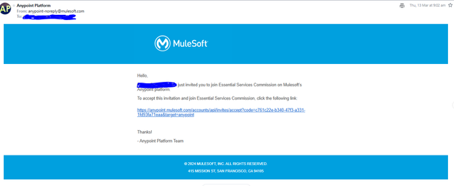
- Click the link and follow the instructions to complete the registration process.
- Select an authentication method and set up authentication.
- You will receive the confirmation via email and the verification code for the successful registration to the new integration platform (MuleSoft).
- Once logged in, you can access the ‘Exchange’ tab on the left side.
- Under the ‘Exchange’ tab, you will find the technical details / specifications for the API.
- The left side menu will show all the authorised API endpoints that you can use as specification for your connection build.
- Before starting any build activity ensure you read the release notes which provide the complete overview in relation to the requesting access.

Notes for build
Account ID: The payload will require two sets of account IDs
- activityData. submittedBy – The account ID of the authorised party which submitted the activity
- activityData. accountId – The account ID associated with the activity
These account IDs will be used to validate the request to ensure the submitter is authorised to create activities on-behalf of the accredited person, as well as for actioning the validations / error notifications for API.

Testing
Once your build is ready, the release notes on the main home page explain how to get the access for calling the API and testing with the commission team.

